Market and Consumer Analysis; Sweet Pea Petals by Jessica Lee
Paulina Zamarripa

Full Sail University

Abstract
Capstone client, Sweet Pea Petals by Jessica Lee online presence is not yet a very strong one but is on the path for great success. As of now, Jessica’s website showcases previous floral arrangements for wedding ceremonies and receptions. Jessica’s business and craft has the potential to thrive once there is a proper online presence for the business. Once the proper tools and elements are set in place Jessica will be able to focus more on her craft while more efficiently maintaining and running her online platforms.

Capstone Thesis Project
Introduction
The main PR Issue for Sweet Pea Petals by Jessica Lee would be with social media because she is not familiar with managing a business on online platforms. Although she has a professional portfolio of her work set in place, she needs help building an online presence. Jessica will have the necessary platforms/programs to reach more followers and clients. Something else Jessica needs help with is deciding on the overall aesthetic and brand look.

Thesis Statement
While word of mouth advertising can still bring in new customers, having strong social media platforms help grow business for Sweet Pea Petals by Jessica Lee and help reach more people.
Situation Analysis
Company Overview and Current State
Jessica Lee runs Sweet Pea Petals by Jessica Lee on her own as a side business. She provides custom made flower arrangements for weddings and high end events. Sweet Pea Petals by Jessica Lee requires to start a branding identity capturing the uniqueness of the services offered will be set in place. This will be finalized within the next week, followed by the incorporation of the logo into the online platforms. Setting SMART goals is key because the specifics of them allow us to better set millstones to better understand where to aim energy. The SMART goals set in place for Jessica Lee are in efforts to increase followers on social media platforms, to increase audience engagement on these platforms, and to grow overall business resulting in more clients. The main PR Issue for Jessica would be with social media because she is not familiar with managing a business on online platforms. Even though Jessica has a professional portfolio of her work set in place, she needs help building an online presence. Once it is built, it is important for Jessica to have a strong understanding and training on the marketing tools she will need to know in order to run and maintain said business once my contract ends.
In efforts to achieve first SMART goal, Jessica will begin taking LinkedIn Learning courses to learn more about digital marketing, so she can maintain and run successful social media campaigns. A tactic will be to follow here would be to review relationships with top influencers as well as successful florists which my client can learn from.
To increase followers a main tactic will be to partner and have social media strategy set in place with well-known social media influencers. As a result, Jessica Lee can tap into their followers as well and as a result growing her business. Adding on there will be continuous efforts on tracking Jessica Lee’s website activity and as a result understanding where the traffic is sourced from. Lastly will be creating case studies every few months to use as a marketing tool.
Other tactics that will be used will consist of Jessica Lee being properly trained in the importance of social media metrics. Following this tactic, Jessica will work towards placing a focus in the areas of Jessica leaves online platforms, where there is room for growth. Another tactic will be connecting with current followers and receiving feedback via surveys to better understand what they wish to see moving forward.
Return on Investment (ROI) will help Jessica Lee better understand whether or not marketing strategies set in place are working to our benefit or not. To start off, Jessica will be studying whether or not we need to invest in more marketing campaigns, pay for more ads, etc. We will know this based on the traffic that is coming into the Sweet Pea Petals by Jessica Lee website. For the second goal, Jessica will know whether or not the projected ROI is working to our benefit by referencing google analytics or site such as Woorank.com. This way, we will better understand our target audience’s online footprint which will project us in a direction to better gauge how to build the online social media strategy. For third goal, Jessica will average the return on investment simply by referencing overall business growth, online following and clientele satisfaction. If the brand has mostly positive recognition, then it means it is on the right tracks for success and overall financial growth.
SWOT Analysis

Jessica is a very hard worker and skilled in creating her intricate floral designs. She truly enjoys the work that goes into creating her unique arrangements. How this impacts the campaign is simply because of the fact that her love for her craft Will speak for itself through her portfolio. It is no secret that Jessica has proven time and time again to go above and beyond and efforts to bring her clients floral dreams to life. These strengths that come naturally to Jessica will be leveraged to the campaigns benefit.
Potential internal struggles that have been expressed relate to fears regarding Jessica not being able to keep up with her side business as she works as a full-time accountant during the week. Jessica is intimidating about the idea that she will have too much on her plate. She runs the side business of hers for the most part on her own with the exception of her husband helping her when he is available. The campaign will leverage these weaknesses to point out the benefits behind hiring a person such as Jessica because she is able to fully commit to placing her attention no more than a couple clients within the same timeline dates. This will prove to be a benefit for both Jessica and her clients because it will allow for her full attention and intimate relationship to take place between herself and her client.
External opportunities that will manifest for Jessica will consist of her allowing to challenge herself on a level she never has professionally. She has stated that “with the new challenges come new learning experiences” (Lee, 2021) for her. Jessica’s ambition to always being open to new challenges will definitely impact the campaign in a positive direction. Although she has a full-time job, she is taking a leap of faith by following a dream of hers to be a small shop owner. A strategy on building her marketing campaign will consist of allowing her followers to follow her to this new journey of hers anticipating that many others will resonate with her story.
Potential external struggles Jessica has expressed consist of the idea that she will not have what it takes to run and maintain her business, and that it will affect her from keeping up with her current full-time job. These concerns related to the campaign will be leveraged simply by reinforcing Jessica’s time management skills. Also is building a self-sufficient marketing campaign with the goal of teaching Jessica how to efficiently maintain it will also be key.
Competitive Analysis (This section should include 3-5 sources of research.)
One of the top competitors in Southern California for weddings is the enchanted florist located in the historic Old Towne Orange first having opened its doors in 1984. Their wedding website is elegant and timeless, and their business is thriving. The business is run by a mother and daughter and it’s open seven days a week delivering floral arrangements and catering to weddings all over Southern California. And obvious difference is the businesses reputation which has been maintained for over thirty years (Enchanted Florist, 2021). It is an established brick and mortar business whereas Jessica is still adding to her clientele list.
A key factor for Jessica will be her understanding of what it takes to launch a start-up. One of the first things will be providing her with courses such as launch your start up intrapreneurship foundations on LinkedIn learning (Kaupe, 2019). This will be one of the efforts to providing her with the marketing fundamentals necessary to scale her business.
The main competitor the enchanted florist offers a wide variety of floral arrangements and has two separate websites one catering solely to wedding clients. Sweet Pea Petal by Jessica Lee for the near future at least will be fully run online and will focus her business efforts on her target audience for the most part consist of weddings and events.
The campaign will differentiate from her competitor social media platforms as they will be more intimate to Jessica Lee’s story. Being in the current economic and political time that we are in, many have been forced out of their jobs. Jessica will not only use her online platforms as a portfolio of her work but also as a platform for her clients to follow her on this new journey of hers.
Problem Statement
A serious problem my client is currently facing is not having the appropriate marketing foundation set in place to allow her business to grow from.
Target Market and Buyer Persona
Jessica began offering her services for weddings in 2015 but has since been approached for other events as well. This has been a side job for her, but she would like to put more focus on it to grow her business locally in Southern California. Target market will typically consist of people planning weddings and requiring custom floral arrangements. For the most part, my age groups will range from 27-37 as they would be established professionals with careers making $57-80k annually. My client’s services will be offered locally in Southern California
According to article by Wedding Wire made in 2020, a national study was conducted concluding with floral arrangements costing on average “around $1,500 with most couples spending between $700 and $2,500” (Wedding Wire, 2020). Important factors come into play in determining cost such as types of flowers, venue size, and custom style. Because of what the prices run at for having fresh flowers as well as the work that goes into creating floral arrangements it is a luxury to have fresh bouquets to fill venues in.
Jessica Lee’s target market will for the most part consist of people 25-37 years old. They will be professionals living in Southern California and ready for the next chapter of their lives. Services will consist of Jessica building vision and vibe boards for her clients leading with branding identity for their business. After that is established, she will work closely with her clients to determine all of the flowers that will be used for the wedding. Additionally, Jessica will source all of the necessary tools and materials that she will be requiring for the event.
Buyer Persona
Amber is 29 years old living in San Diego California and she is a professional nutritionist running her own practice making $80K a year and her husband is a civil engineer making $110K a year. Amber has a clear vision of how she sees her wedding coming to life. She wants every single flower used for her wedding and venue to be white with hints of natural green leaves surrounding them. She is planning on having an intimate wedding as the pandemic is still among us so her wedding will consist of no more than 95 guests will take place in Newport Beach California, with budget being no more than $10,000 on flowers.

Figure:1 Bride to be photographed by Kyle Roxas (2021) (Pexels)

Secondary Research
Jessica averages the return on investment simply by referencing overall business growth, online following and clientele satisfaction. If the brand has mostly positive recognition, then it means it is on the right tracks for success and overall financial growth. Holding more focus groups and conducting in-depth surveys or even E-blasts to customers will provide analytical data and help overall business. Various other tactics can come into account benefiting projected ROI. We will know whether or not the project at our away is working to our benefit by referencing Google analytics as well as providing Jessica with fundamental tools she will need once I am no longer managing her online platforms. While gathering said analytical data there can also be benefits from looking at what my client has done in the past, learning more from her target audience, and identifying what my client’s strengths and weaknesses are as a young entrepreneur.
For brides-to-be, Sweet Pea Petals by Jessica Lee is the floral arrangement go-to that provides exquisite custom services for weddings big and small because of my client’s ability in providing the personal touch and effective communication needed to bring to life the weddings in which dreams are made of. The target audience identifies having strong, communication throughout this entire process an important factor when deciding on picking a floral company for their wedding. Overall, Jessica Lee wants her floral arrangements to bring her clients joy while making their special events memorable by taking off the stress from the bride and grooms boulders when it comes two floral arrangements.
Although Jessica has a strong portfolio of the previous weddings that she has worked on she has no online presence nor branding for her business. This becomes a problem for somebody who is looking to expand their business because she does not have the appropriate foundation set in place for the business to grow. This will affect any potential efforts to growing her target audience via social media, which will naturally keep her business from growing. For somebody who is not looking to grow clients this is not a problem. Jessica could in fact continue to work as she has been in the past which is being referred from brides she has worked with. Why this becomes a problem is because Jessica does in fact want to grow her business and does not want to depend on referrals and waiting for her next friend’s relatives to get married. Social media has become a key tool for anybody looking to reach more people, regardless of whether they have a business they are marketing or not. Also allowing for a proper branding of said business brings a level of profession that is necessary and key to any successful business (Liehuang Zhu, 2012). Once an elegant and consistent branding series is set in place that ties into Jessica’s online platforms, website, emails, printing collateral etc. she will then have the proper fundamental tools necessary to grow her business.
Because Jessica is a young entrepreneur working towards one day making this her full-time job she is very open to learning and doing everything she can to fulfill the stream of hers. According to Time to Start Your Start Up course on LinkedIn Learning “knowing where you stand and where you want to go is key to any start up.” (LinkedIn Learning 2020). This course proved to be important for my client because from the very beginning she was unsure if building this side business of hers was something that she was ready to fully commit to. It also pointed out important tips which Jessica can benefit from that will help her build on her time management skills. This course has also helped build a financing model which will be important moving forward as we build her website.
Consistency in branding is extremely important in a business, it will be important to maintain same branding across all social media platforms. As article states “hyperconnectivity has allowed existing brands to expand their geographic reach and societal rules while new types of branded entities are further stretching the branding space.” (Swaminathan 2020). Especially during these highly virtual times amidst social distancing, having a strong sense of branding across multiple digital platforms is important in order to maintain consistency and customer connectivity.
KPI’s also known as key performance indicators can be even more beneficial when using them alongside of creating smart goals because we as PR practitioners are then able to track analytics while understanding the data in order to make decisions to better improve the areas in which performance can be improved. As the article states “The right set of [key performance] indicators will shine light on performance and highlight areas that need attention” (Marr, 2011). By setting smart, measurable, achievable, realistic, and timely goals also known as SMART goals will prove to be extremely beneficial in the long run by being able to identify the metrics.
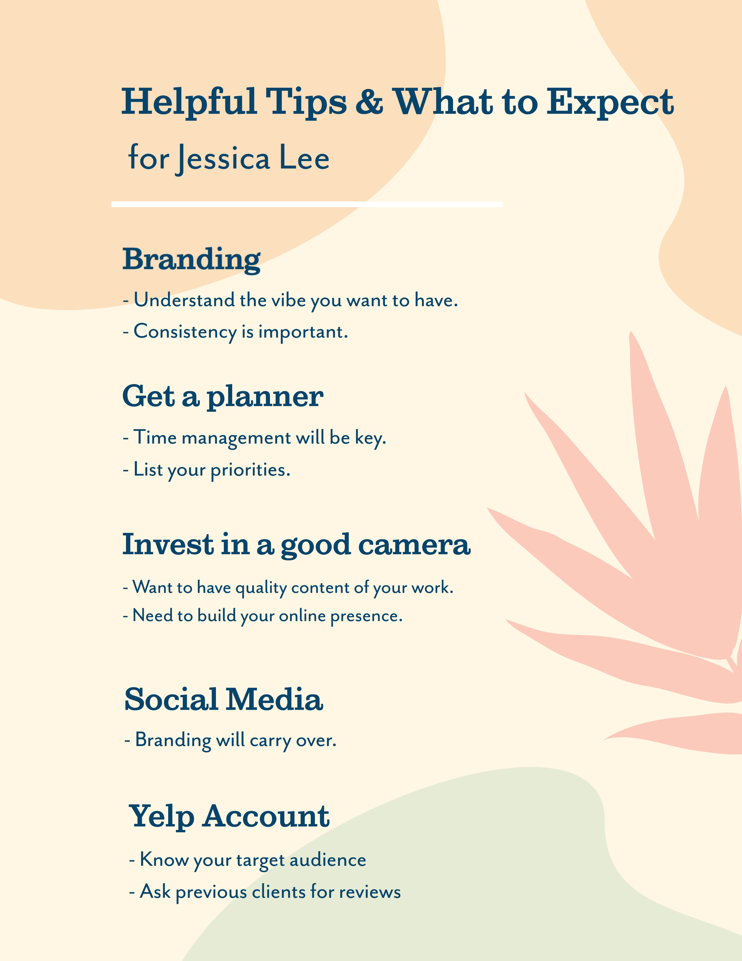
Figure 2: Helpful Tips & What to Expect (Liehuang, 2019)
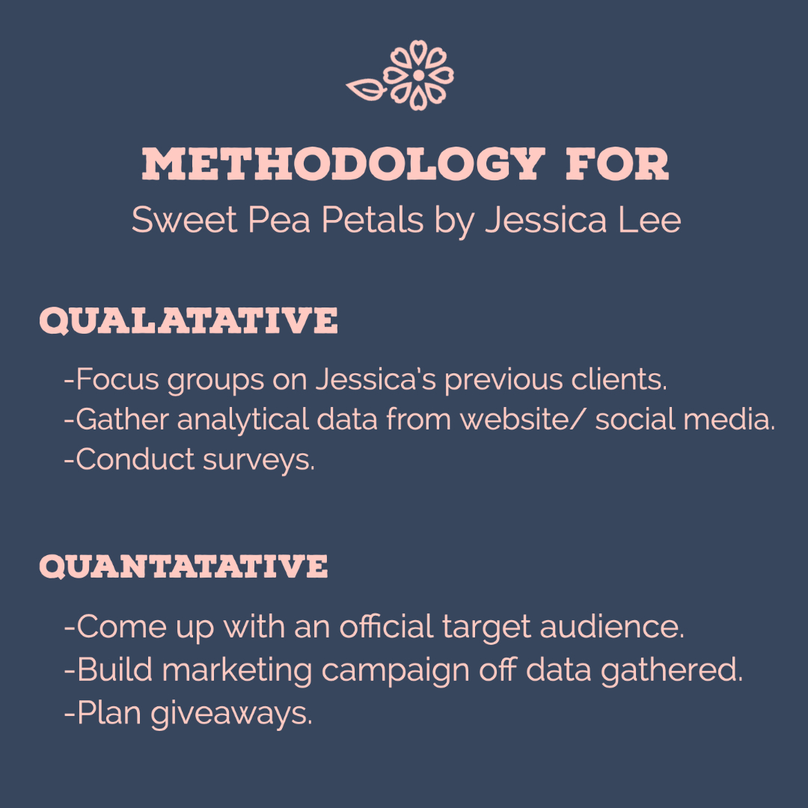
Figure 3: Methodology (Lohman, 2019)
Primary Research Design
For primary research, there have been a few survey questions created in efforts to hear more from target audience. A focus group consisting of seven people who have recently become engaged as well as people who have gone through the process of hosting a wedding have been used for survey. There is value in asking people who have gotten married even though they may not fall directly under my client’s target audience because they have gone through the process and have valid feedback that can be beneficial for us.
The design of the survey is to shine a light on what clients wish to see on the website as well as bringing forward potential do’s and don’ts. The questions that will be asked are as follows:
- Would a simple pick and order website help out or make it easier to choose floral packages for your wedding?
- Would you prefer one on one meetings to create custom floral arrangements?
- Would it make it easier for you if premade bouquets are displayed to see if that is what you want?
- Would having a physical store be better than online to see the bouquet options?
- Would you consider using a florist other than for a wedding?

Primary Research Findings
Based on the overview and discussion of findings the overall study resulted in positive feedback from the focus group. A strong finding has been that although the bride and groom would benefit in having premade floral arrangements, they do not mind putting in the extra time and money for custom floral arrangements. Every wedding has its own unique style, and it has been brought up that the kind of flowers and color palettes used or in fact a very intimate detail for the bride and groom. While some may want bright and vivid colors others more neutral and subtle tones.
Another helpful piece of information that came out of this focus group was how important having one on one meetings over a brick-and-mortar store would be. Two of the people interviewed had to postpone their wedding last year because of the pandemic and being able to have virtual meetings and effective communication throughout the postponing of his and her weddings was extremely helpful.
Although the focus group would have benefited and having more participants the findings we’re still very helpful. Another finding was that even though one of the persons wedding had to be postponed and then being forced to uninvite more than half of her guests because of southern California regulations having beautiful fresh and custom floral arrangements was very important to her.
Conclusion
In conclusion, Sweet Pea Petals by Jessica Lee will be able to grow her business more effectively once she has her social media platforms set up properly. By gathering analytics and studying her target audience it will better prepare her and coming up with a strong marketing strategy. Especially during the pandemic that we are in right now being able to run her business will depend much on how well she is able to adapt to the virtual business aspect in her industry.

References
Alan, W. (2019, April 12). What is a KPI? Retrieved January 31, 2021, from https://www.youtube.com/watch?v=HJNHT_1aUao
Kaupe, K. (2019, August 16). Launch your startup - Entrepreneurship Foundations video TUTORIAL: Linkedin learning, formerly Lynda.com. Retrieved February 08, 2021, from https://www.linkedin.com/learning/entrepreneurship-foundations-2/launch-your-startup?u=50813145
Liehuang Zhu, Keke Gai, & Meng Li. (2019). Blockchain Technology in Internet of Things. Springer.
Lohmann, G., Pratt, M. A., Benckendorff, P., Strickland, P., Reynolds, P., & Whitelaw, P. A. (2019). Online business simulations: authentic teamwork, learning outcomes, and satisfaction. Higher Education (00181560), 77(3), 455–472. https://doi.org/10.1007/s10734-018-0282-x
Marr, B. (n.d.). Key performance indicators (kpi). Retrieved February 22, 2021, from https://books.google.com/books?hl=en&amp;lr=&amp;id=WleQ-F6WC3sC&amp;oi=fnd&amp;pg=PT24&amp;dq=KPI%2Band%2Bqualitative&amp;ots=3wFwc93E_7&amp;sig=drzVkbIxVSwiq_cZpa0yUqoeEYY#v=onepage&amp;q=KPI%20and%20qualitative&amp;f=false
MEHTA, A. (2018, November 30). Your big day blooms: TOP WEDDING FLORAL ARRANGEMENT TIPS FROM EXPERT DIKSHA PATEL. Eastern Eye, 1484, 31.
Rajkumar Venkatesan, Paul W. Farris, & Ronald T. Wilcox. (2021). Marketing Analytics : Essential Tools for Data- Driven Decisions. University of Virginia Press.
Richard L. Brandt. (2011). One Click : Jeff Bezos and the Rise of Amazon.com. Portfolio.
SCHUPAK, H. (2021). Business is Blooming. Family Business, 32(1), 64–63.
Stefan Niemeier, Andrea Zocchi, & Marco Catena. (2013). Reshaping Retail : Why Technology Is Transforming the
Swaminathan, V., Sorescu, A., Steenkamp, J.-B. E. M., O’Guinn, T. C. G., & Schmitt, B. (2020). Branding in a Hyperconnected World: Refocusing Theories and Rethinking Boundaries. Journal of Marketing, 84(2), 24–46. https://doi.org/10.1177/0022242919899905

T. (n.d.). About us. Retrieved February 14, 2021, from https://enchantedfloristorange.com/about
The Complete SEO Tool Suite for Digital Marketing: WooRank. (2021). Retrieved January 17, 2021, from https://www.woorank.com/
SharesTweet, 0. (2020, March 08). How to Develop a Web Strategy From Scratch [Step-by-Step]. Retrieved January 17, 2021, from https://www.bluewiremedia.com.au/web-strategy
W. (2020). Wedding Flowers Cost Guide. Retrieved February 22, 2021, from https://www.weddingwire.com/cost/wedding-flowers
World Bank, & International Finance Corporation. (2012). Doing Business in a More Transparent World : Comparing Regulation for Domestic Firms in 183 Countries. World Bank Publications

